Tanweer Molla

Lab Partner: Alex King

November 29, 2012

Mahalov/Everett

**%Original code for picture:**

A=imread('cauchybw.jpg');

B=double(A(:,:,1))+1;

B=B/256

[U,S,V]=svd(B);

**%Question1**

>> sizeu=size(U)

sizes=size(S)

sizev=size(V)

sizeu =

310 310

sizes =

310 338

sizev =

338 338

**%the dimension of U is 310x310**

**%the dimension of S is 310x338**

**%the dimensions of V is 338x338**

**%problem2**

rank1=S(1,1)*U(:,1)*V(:,1)';

C=zeros(size(A));

C(:,:,1)=rank1;

C(:,:,2)=rank1;

C(:,:,3)=rank1;

C=max(0,min(1,C));

figure(1)

image(C)

**IMAGE ON NEXT PAGE**

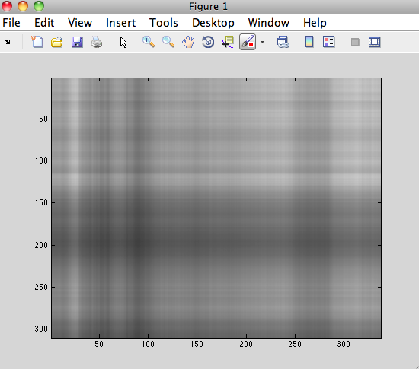

**%problem3**

rank10=zeros(size(B));

for i=1:10

rank10=rank10+S(i,i)*U(:,i)*V(:,i)';

end

C=zeros(size(A));

C(:,:,1)=rank10;

C(:,:,2)=rank10;

C(:,:,3)=rank10;

C=max(0,min(1,C));

figure(2)

image(C)

**IMAGE ON NEXT PAGE**

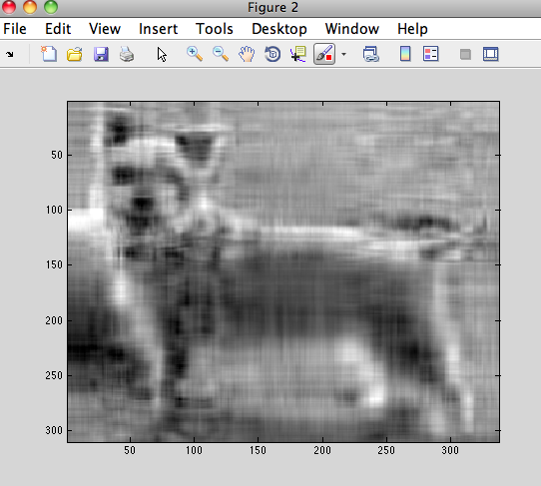

**%Problem 4**

rank50 = zeros(size(B));

for i = 1:50

rank50 = rank50+S(i,i)*U(:,i)*V(:,i)';

end

C = zeros(size(A));

C(:,:,1) = rank50;

C(:,:,2) = rank50;

C(:,:,3) = rank50;

C = max(0,min(1,C));

figure(3)

image(C)

**IMAGE ON NEXT PAGE**

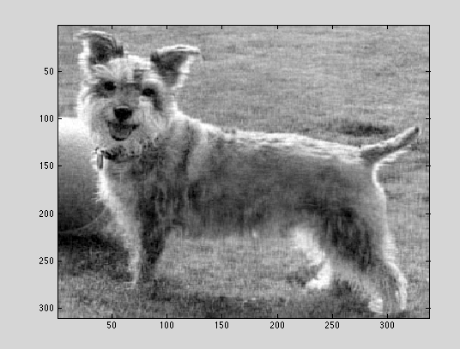

**%A rank of 50 gave me a pretty approximate solution to the original picture.**

**%Problem5**

**%310 reproduces the right rank of the picture.**

rank310 = zeros(size(B));

for i = 1:310

rank310 = rank310+S(i,i)*U(:,i)*V(:,i)';

end

C = zeros(size(A));

C(:,:,1) = rank310;

C(:,:,2) = rank310;

C(:,:,3) = rank310;

C = max(0,min(1,C));

figure(3)

image(C)

rank(B)

IMAGE ON NEXT PAGE

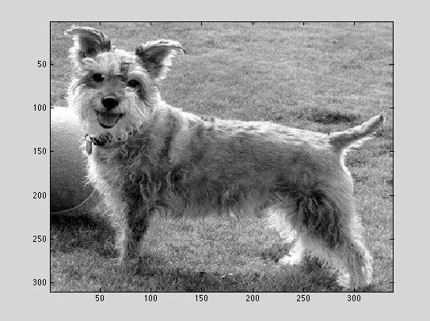

**%Question 6**:

m = 310;

n = 338;

k = 53;

CR = (k*(m+n+1))/(m*n)

CR =

0.3283

**%CR = .3283 or 32.83%**

**%32.83% was compression rate of the approximation of the original image.**

**%The rate represents that 32.83% of the original image was used as the %approximation.**

**%Question 7**

>> m = 310;

n = 338;

CR = 1;

k = (CR*m*n)/(m+n+1)

k =

161.4484

**% k=161.4484 will give the same amount of data as the original picture given. This %scenario, we rounded up because when rounded down, it will give less data than %the original picture given, we always need the minimum required data that is the %same amount as the original picture.**